**Ideation Phase**

**Define the Problem Statements**

|  |  |
| --- | --- |
| Date | 10 October 2022 |
| Team ID | PNT2022TMID21840 |
| Project Name | Project -Web Phishing Detection |
| Maximum Marks | 2 Marks |

**Customer Problem Statement Template:**

An online user needed to purchase something through an online. So, he entered into the online website through internet. It takes some time to display the product. He started to see all the products. He search the necessary things in online website. At last, he found the needed products. After that he entered all the credit card details, username and password for purchasing the things through online. Then he received the message "Your order is placed and transaction is successfully completed. You will receive the ordered product within 2 days”. After that within 24 hours he got a message in mobile and the bank account was empty then the customer shocked.Then only he realized that was a fake website and his bank account details was stolen by hacker .To avoid this scenario. We need to solve this problem by using the Web Phishing Detection.

|  |  |
| --- | --- |
| I am | An online user |
| I’m trying to | Purchase some necessary things through an online website. |
| But | It takes some time for display of the products. |
| Because | Some illegal websites are using normal websites name for stealing my sensitive details such as credit card details, username, password, etc.. |
| Which makes me feel | Unsafe and frustrated while using fake websites. |

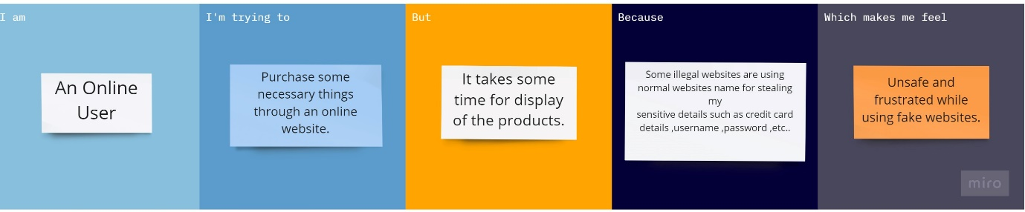

|  |  |  |  |  |  |
| --- | --- | --- | --- | --- | --- |
| **Problem Statement (PS)** | **I am (Customer)** | **I’m trying to** | **But** | **Because** | **Which makes me feel** |
| PS-1 | An Online user | Purchase some necessary things through an online website. | It takes some time for display of the products. | Some illegal websites are name for stealing my sensitive details such as credit card details, password ,etc., | Unsafe and frustrated while using fake websites. |
| PS-2 | Customer | Open an website in the browser | Some websites are not secure and our details got stolen. | We may not be aware of the secure or infectious websites. | That our information gets stolen and our bank details gets hacked by the fake web users. |